DIGITAL MODULATION AND ITS TYPES

20PW09 – DHIVYA DHARSHNI S V

What Is Digital Modulation?

Before that, a recap of what modulation actually means : **Modulation** is a process of mixing signals with a sinusoid to produce a new form of signals. The newly produced signal has certain benefits over an un-modulated signal. Mixing of low-frequency signal with a high-frequency carrier signal is called Modulation.

The modulation method in which discrete signals are used to modulate carrier waves and remove noise from the waves is known as digital modulation.

Digital Modulation Types  
1) Amplitude shift key (ASK)  
2) Frequency shift key (FSK)  
3) Phase shift key (PSK)

**Amplitude Shift Key (ASK) Modulation**

* As the name suggests, in Amplitude Shift Key or ASKS Modulation, the amplitude is represented by "1," and if the amplitude does not exist, it is represented by "0".
* Using Amplitude Shift Key Modulation is very simple, and it requires a very low bandwidth.

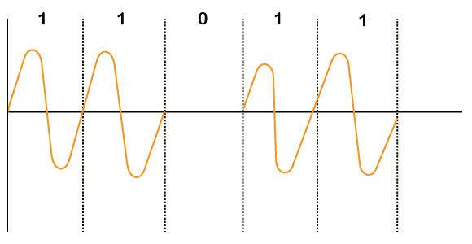

**Frequency Shift Key (FSK) Modulation**

* In Frequency Shift Key or FSK Modulation, different notations f1 and f2 are used for different frequencies.
* Here, f1 is used to represent bit "1," and f2 represents bit "0".
* It is also a simple modulation technique but uses different frequencies for different bits; bandwidth requirement becomes high.

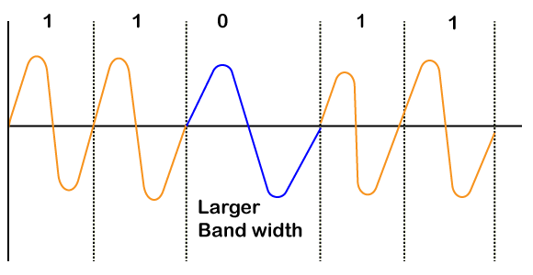

**Phase Shift Key (PSK) Modulation**

* In Phase Shift Key or PSK Modulation, the phase difference is used to differentiate between the "1" and "0" bits.
* If the bit is "1", a simple wave is drawn, and if the bit becomes "0", the phase of the wave is shifted by "180 or π".
* PSK Modulation is more complicated than ASK and FSK Modulation, but it is robust too.

